EX:NO:08 SOFTWARE PERSONAL MANAGEMENT SYSTEM

USECASE DIAGRAM:
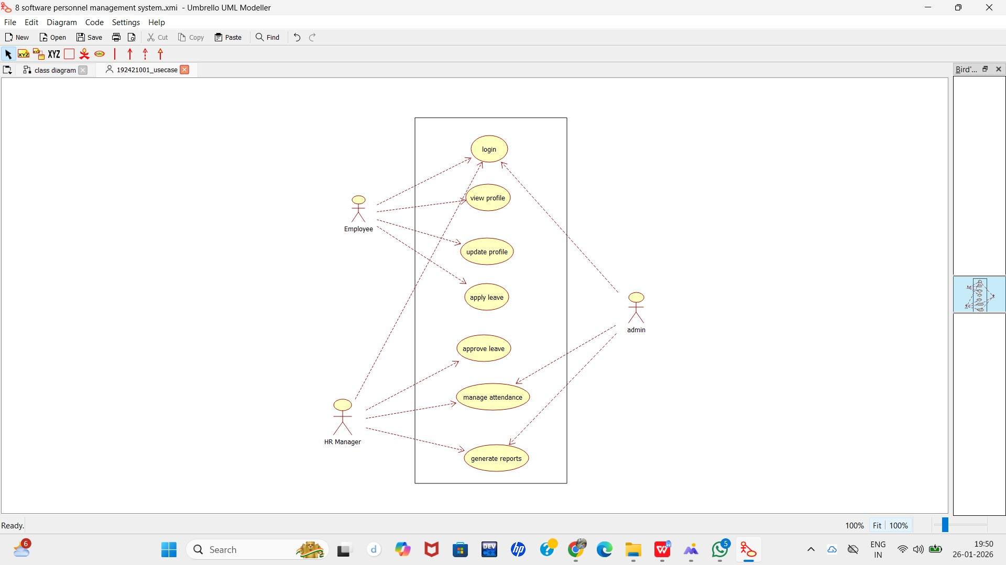

CLASS DIAGRAM:

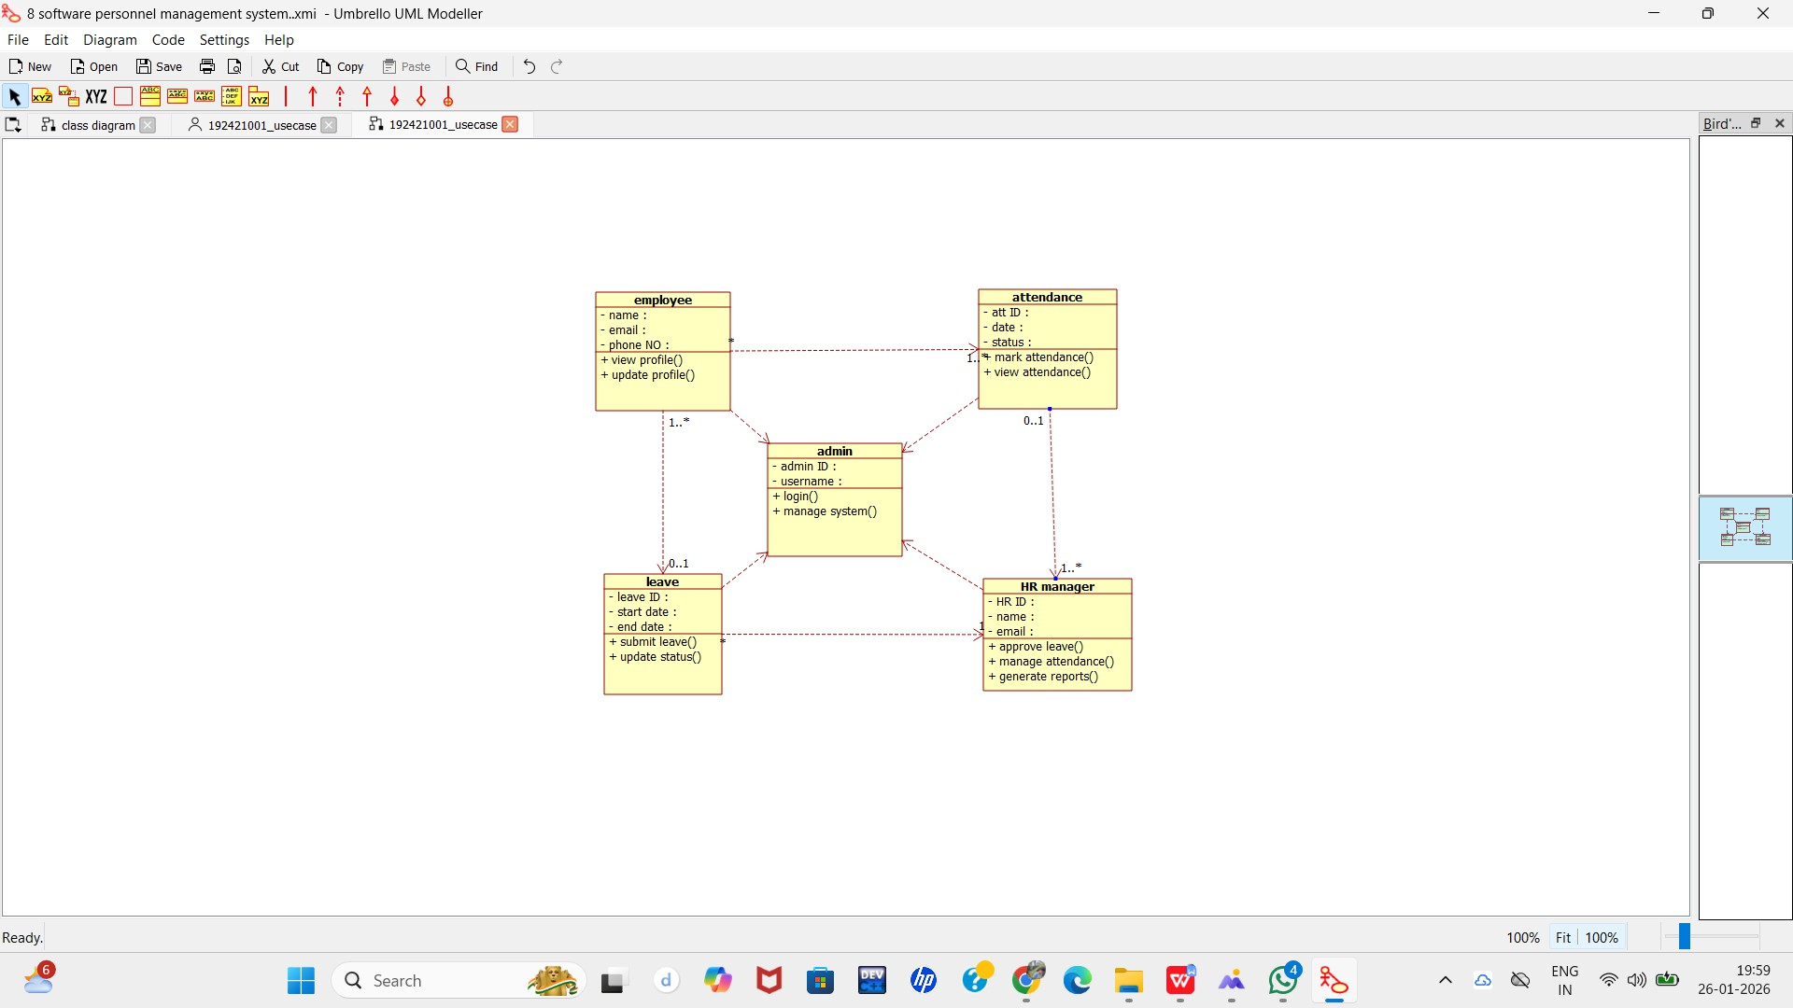

ACTIVITY DIAGRAM:

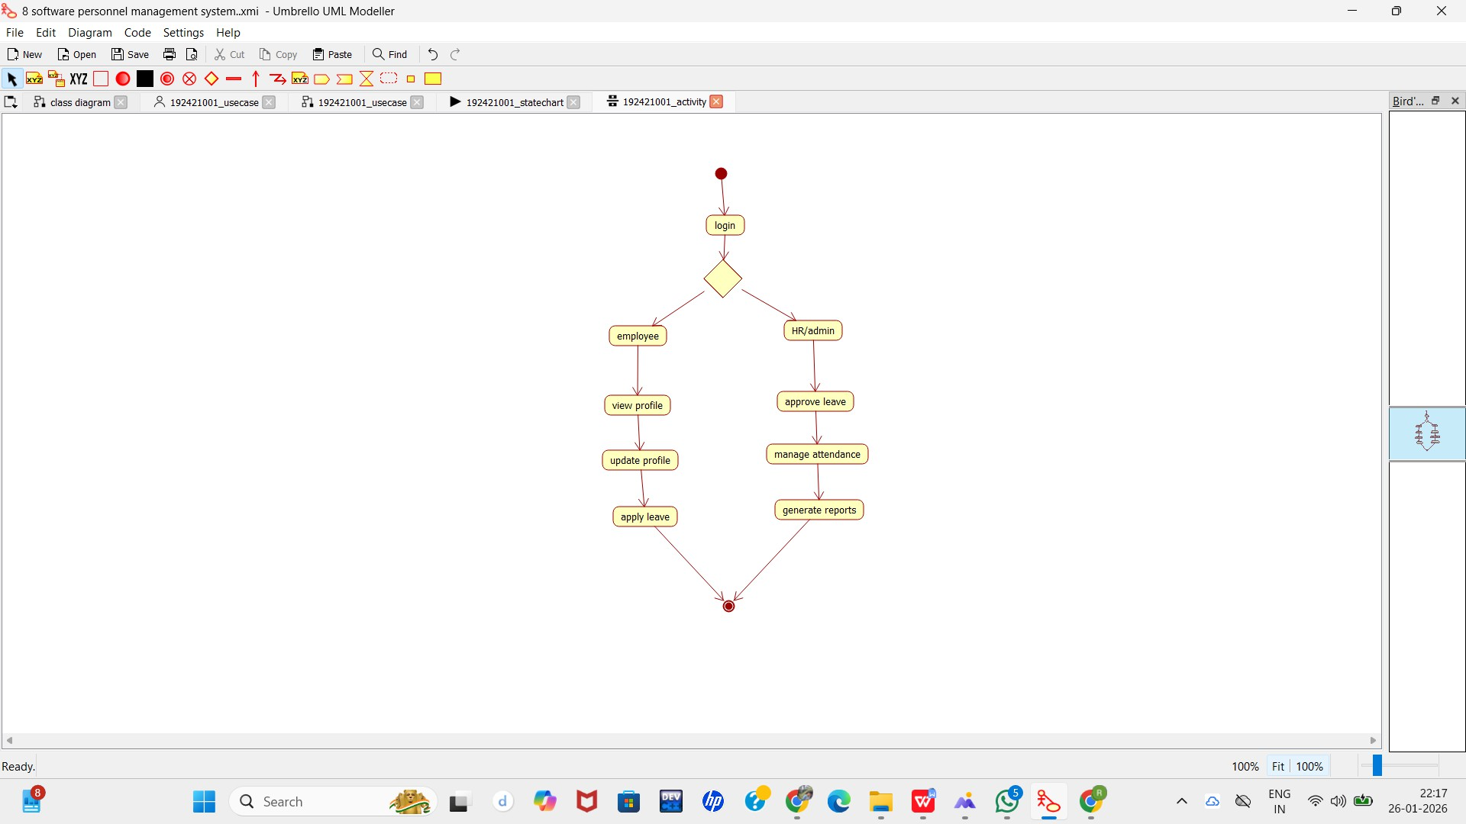

SEQUENCE DIAGRAM:

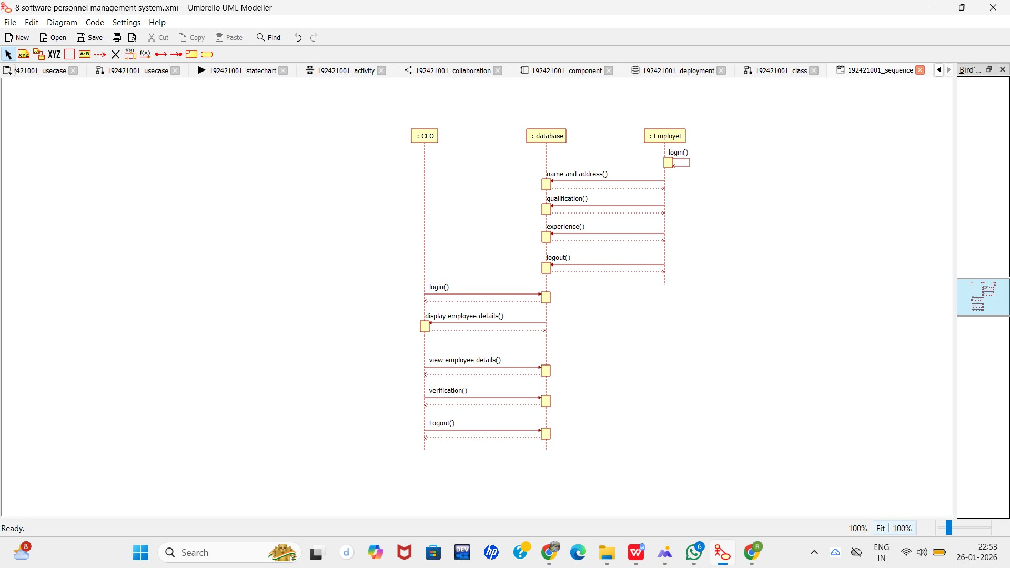

COLLABORATION DIAGRAM:
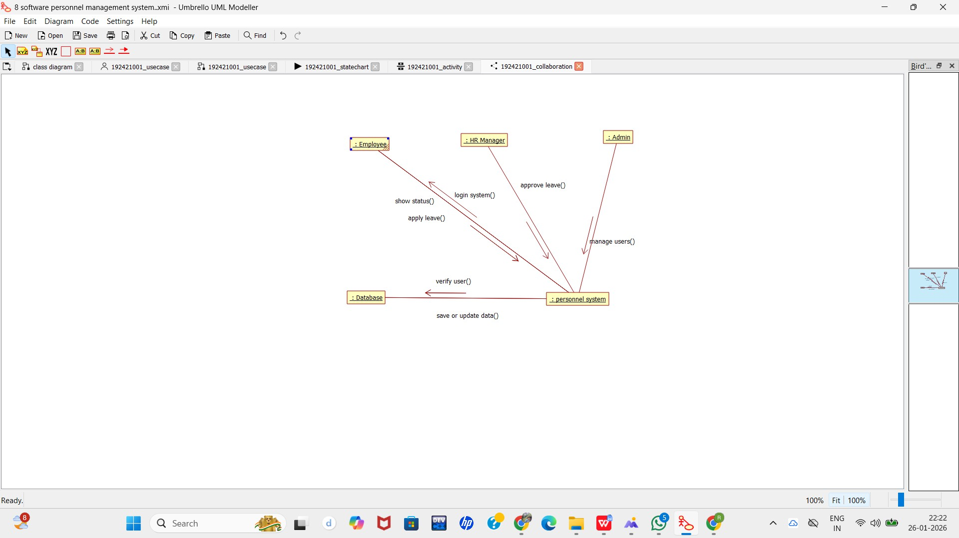

STATECHART DIAGRAM:

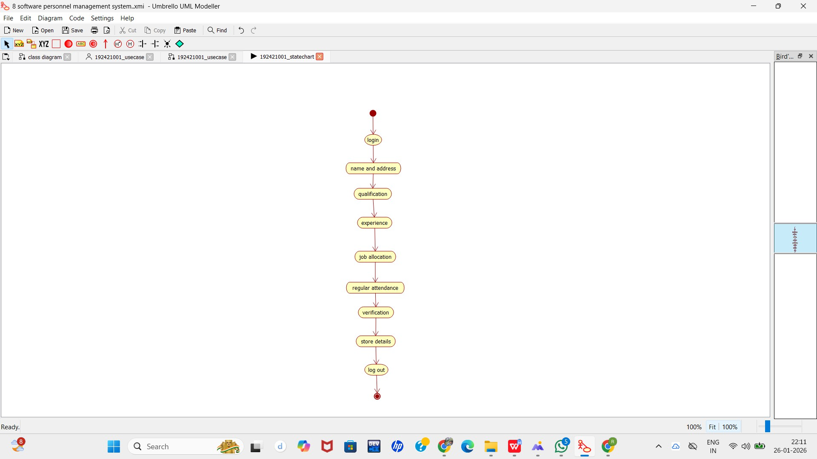
.

COMPONENT DIAGRAM:

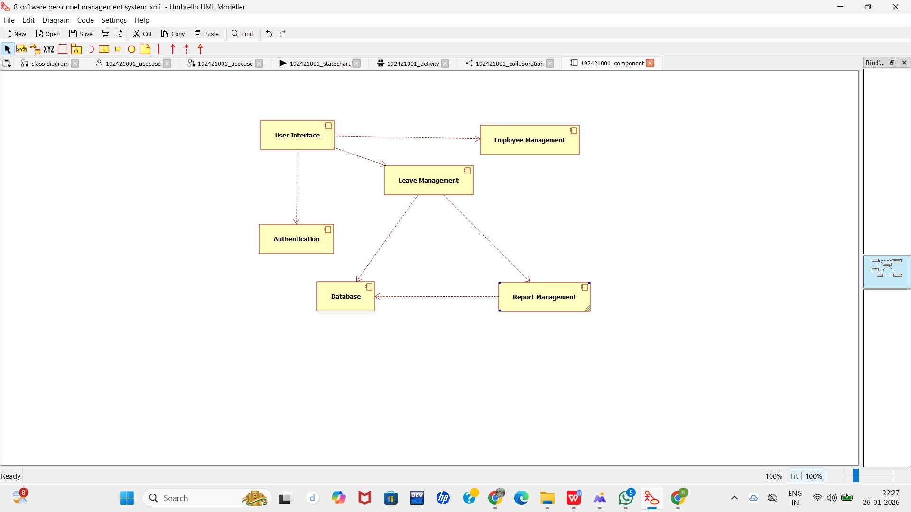

DEPLOYMENT DIAGRAM:

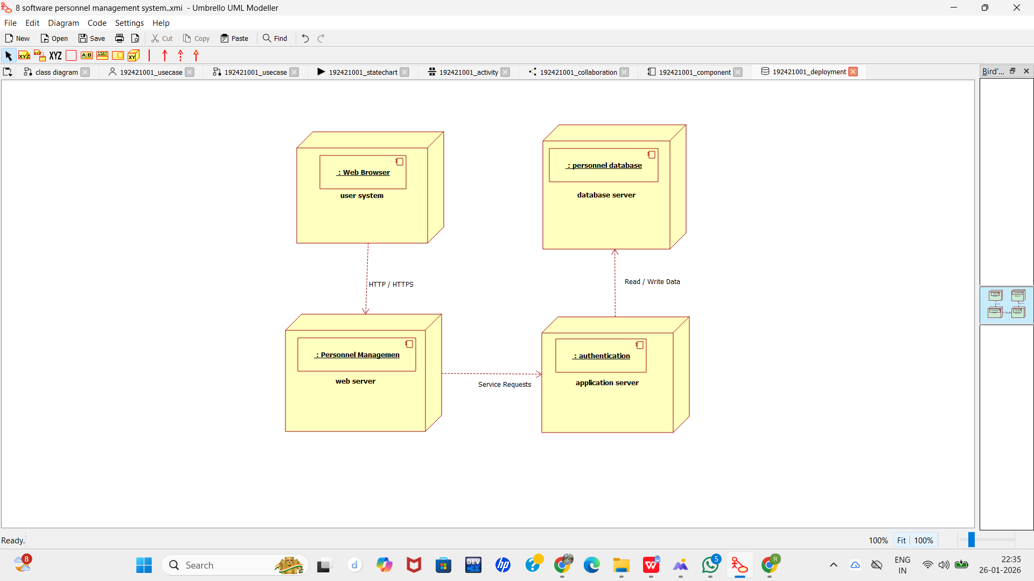

PACKAGE DIAGRAM:
